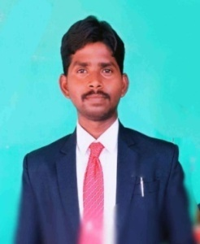
Academic Proficiency

- Completed M.Ped First Class From Sri KrishnadevarayaUniversity,Ananthapur.

- Completed B.Ped First Class From G.C.P.E,Osmania University, Hyderabad

- Completed B.A From K.HGovernament Degree College, Dharmavaram.

- Completed Intermediated From Govt.Juniorcollege(Boys) Dharmavaram.

- Completed S.S.C Govt. High School Dharmavaram.

DEPARTMENT OF PHYSICAL EDUCATION




Academic Distinction

- Participate In The Junior National Tournament And Secured Runner’s ( Silver Medal ) In Ball Badminton

- Participate In The S.K University Inter Collegiate Tournament And Secured Winner’s In Tabletennis

- Participate In The S.K University Inter Collegiate Tournament And Secured Runner’s In Ball Badminton

- Participated in Ball Badminton in National Level 2014.from Sri Krishnadevaraya University.

- Participated in Ball Badminton in National Level 2019 from Sri Krishnadevaraya University.

- Participated in Ball Badminton in National Level 2015 from Osmania University

- Participated in Table Tennis in South Zone Level 2018 from Sri Krishnadevaraya University

Medals /Awards/ Appreciation Received

- Atleast Five To Six Players Participate In The All India/South Zone Inter University Tournament
- One Player Represented In ACE Kabaddi International League Seson 2022

PAPER SETTER
Acted As Selection Committe Member Of SK University Inter-University Teams

Orientation & Skill Development Courses
Completed 6 Months Yoga Instructor Course (YIC)

P Personal Profile Of Sri B.Anand In Physical Education,
K.H Govt. Degree College, Dharmavaram.

Position Held
Team Manager Of S.K University Teams Last 3 Yeras

AS RESOURCE PERSON

Selection Committee Member In SKU Inter University Collegiate Games And Sports

Excercise Physiology And Training Methods

Specialization

Teaching Experience
4 Years

9491816892 / 891900141

bathenaanand7s@Gmail.com

28-483, Rajendra Nagar
Dharmavaram, 515671

